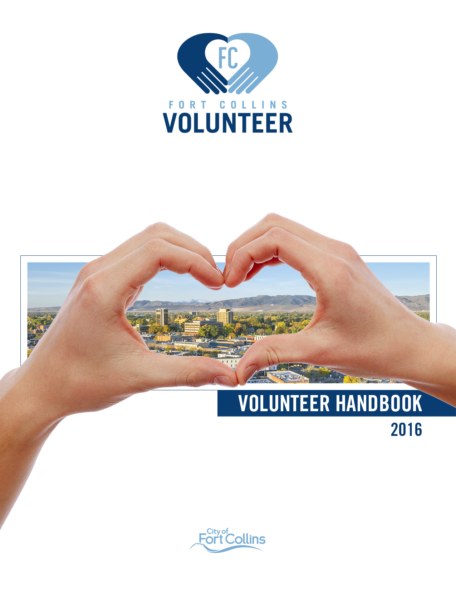
2023

Table of Contents

Table of Contents 2
Guiding Principles 3
Safety 4
Policies 6
Code of Conduct 10
Forms 11
Volunteer Benefits 13
Thank You 13
Volunteer Agreement 14

Guiding Principles

City Vision, Mission, Values

Vision
To provide world-class municipal services through operational excellence and a culture of innovation.

Mission
Exceptional service for an exceptional community.

Values
- Collaboration
- Excellence
- Integrity
- Outstanding Service
- Safety & Well-being
- Stewardship

Volunteer Services Vision and Mission

Vision
Strengthen the Fort Collins community by activating volunteerism guided by stewardship, inclusion, and impact.

Mission
Promote volunteer involvement to improve services and create community

Values
The City is guided by six values, which also apply directly to volunteer engagement.

- Collaboration: Partnership between volunteers and employees drives value and impact.
- Excellence: We strive for quality in supporting volunteers with resources for success.
- Integrity: We honor volunteers and their contributions through honesty and respect.
- Outstanding Service: We provide volunteers exceptional support so they can have exceptional impact.
- Safety and Wellbeing: We prioritize the mental, physical, and emotional safety and wellness of our volunteer partners.
- Stewardship: We cultivate partnerships with volunteers and nurture that relationship ongoingly.

Safety

Body Mechanics
Take special care to how you lift, stand, sit, and move during your volunteer duties to prevent injury.

Clothing and Personal Protective Equipment
Wear the appropriate clothing and personal protective equipment as outlined by your supervisor.

Emergency Response
Staff will provide instruction In the event of an emergency. If an evacuation is necessary, move as quickly and orderly as possible and proceed to your designated meeting area.
Staff will also teach you the location of first aid kits and AED in case of a medical emergency. Call 911 if necessary.

Incident Reporting
Any volunteer involved in an incident during the course of their volunteer duties or a near miss must report the incident to their department Volunteer Manager or supervisor as soon as possible. Each volunteer must also report any unsafe working conditions, equipment or practices to their department Volunteer Manager or supervisor as soon as possible. An incident may be defined as something noteworthy or out of the ordinary that resulted in injury, property damage or could have potentially resulted in one of these.

Slips, Trips, and Falls
Look on the ground for changes in flooring height, spilled liquids, and tripping hazards. Report hazards to your supervisor.

Training
City supervising staff will provide safety training to volunteers specific to the task the volunteer will be performing. Training shall include the potential hazards the volunteer may encounter and how to protect themselves from those hazards including the issuance and use of personal protective equipment (PPE).

Policies

Age Requirements
It is the discretion of each volunteer program in the City whether to accept youth volunteers under the age of 18, including what ages of volunteers they will accept, and what ages volunteers can participate unsupervised by a parent or guardian.

Attendance and Commitment
Volunteers will give as much notice as reasonably possible to their supervisor if they will be late for or absent from a volunteer shift. By applying to a volunteer opportunity, volunteers agree to commit to the volunteer position for a period of time listed in the volunteer position description. If for any reason a volunteer becomes inactive, including for extended vacation or medical leave, volunteers must notify a supervisor. Volunteers who do not return after one year will be considered inactive.

Confidentiality
Volunteers must respect the confidentiality of materials, records, and information that you may come into contact with during the course of their volunteer experience. Confidential information may include personnel records, financial information, privileged communication, etc. Some assignments may require the completion of a confidentiality agreement.

Customer Service Standards
Volunteers are expected to provide a high-level of customer service to exhibit visitors in accordance with the City’s mission, “Exceptional service for an exceptional community.”

Difficult Visitors
Difficult visitors and customers should be directed to a paid staff member. Volunteers that find themselves in a situation where they feel uncomfortable, should involve their department’s Volunteer Manager.

Dismissal
Either a volunteer or the City may terminate a volunteer opportunity at will at any time with or without cause or notice. Cause for termination of a volunteer opportunity includes but is not limited to violation of any of the requirements or Code of Conduct contained in the Volunteer Policies and Procedures or Volunteer Handbook.

Exit Survey
In the spirit of continuous improvement and data collection, the City of Fort Collins asks that all volunteers leaving their volunteer position fill out an exit survey. The survey can be found at fcgov.com/volunteer.

Grievances
Promoting positive relationships between volunteers and City employees is key to the operations of the City of Fort Collins. Volunteers are urged to discuss any grievances with their department Volunteer Manager, or the Volunteer Services Program Manager.

Hours
Volunteers must keep accurate records of the time spent volunteering, days and times, and report to the department’s Volunteer Manager.

Identification Badges
Long-term volunteers and interns are required to wear their identification badge at all times during their volunteer duties for security purposes. All volunteers must return their identification badges to their department’s Volunteer Manager or supervisor upon resignation, completion, or termination of their volunteer status with the City.

Intellectual Property Policy
Intellectual or physical property developed by volunteers during City of Fort Collins volunteer activities becomes and is the property of the City of Fort Collins.

Media Contact
Volunteers are not authorized to speak to the media about their volunteer duties or during their volunteer activities unless City staff consents. Media contacts will likely be pre-arranged, and the volunteer will be notified.

Orientation
Volunteers must attend a Volunteer Orientation, either by attending a presentation with a Volunteer Services Program team member or through their own department training. Virtual orientations are also available.

Policy Changes
Updates to this Volunteer Handbook will be published at fcgov.com/volunteer.

Representing the City
As an affiliate of the City, residents and customers may not be aware of the unpaid status of a volunteer, but only perceive them as a representative of the City government. Volunteers are responsible for representing the City in a positive way while on duty or wearing a volunteer uniform or name badge.

Smoking, Drugs and Alcohol
Volunteers are not permitted to smoke, use alcohol, marijuana or illegal substances while volunteering for or representing the City, nor to bring them into any City facility. Smoking is prohibited on all City property including parks, natural areas and trails.

Talent Release
By registering as a volunteer, the City has the right to capture, reproduce, edit and distribute broadcast audio or visual media of the volunteer without payment of fees.

Uniforms
Uniforms are determined by the discretion of each volunteer program. All volunteers must wear some sort of volunteer identifier. When not provided by the department, FC Volunteer t-shirts are available through Volunteer Services.
Recommended volunteer dress for outdoor assignments:
- Pants – comfortable pants to prevent scrapes and sun damage
- Shirt – City-provided volunteer tee-shirt or polo shirt with “Volunteer” clearly marked
- Footwear – closed-toed shoes or boots
- Headwear – headwear is not required, acceptable headwear includes a cap or visor

Volunteer Records
The City will collect information about volunteers during the application process. Volunteer information collected by the City is confidential and will not be shared and/or sold. Volunteer records may be deleted after 5 years.

Volunteer Directory
Volunteers are encouraged to explore opportunities with any City departments. Current volunteer opportunities can be found at the Get Involved Page

Working for the Public
Volunteers for the City act in the public trust. Volunteers will disclose any potential for conflict of interest or appearance thereof to their supervisor. Volunteers cannot accept gifts or favors in excess of $50 from residents or customers in the course of their work and are subject to the conflict of interest requirements described in the Fort Collins Charter at Article IV, §9 and the Fort Collins Municipal Code at §2-568.

Code of Conduct
Although it is impossible to predict every possible type of volunteer misconduct, the following are some of the types of conduct that could lead to termination of volunteer opportunity:
- Theft or misuse of City money or property;
- Commission or conviction of a felony or of any crime involving moral turpitude;
- Violation of any departmental or City rule, regulation, policy or procedure;
- Harassment of, or discrimination against, any individual based on race, color, religion, sex, national origin, age, disability, sexual orientation, genetic information, or any other characteristic protected by the law;
- Falsification, unauthorized use or destruction of City records, reports or other data or information belonging to the City;
- Abusive or threatening treatment of any person, including, but not limited to physical or verbal confrontation;
- Insubordination or refusal to comply with directives or assignments;
- Using, consuming, possessing, having in the body, or distributing alcohol or controlled substances during working time or while operating a vehicle to conduct City business;
- Incompetence, inattention to duties or wastefulness while on the job;
- Failure to meet performance expectations of job or not performing duties or functions assigned;
- Repeated tardiness or absenteeism;
- Failure to properly use safety equipment, clothing or equipment or failure to follow established safety procedures;
- Destruction, loss or abuse of City property;
- Unauthorized use of City vehicles, equipment or property for personal use;
- Possessing or maintaining sexually explicit materials on City property or in a City vehicle without a valid, work-related purpose. Sexually explicit materials shall mean any pictures, drawings, electronic reproductions, or other visual reproductions depicting the genitals, depicting sexual acts, or depicting an image which could reasonably be construed as conveying a sexually erotic theme.
- Non-volunteer conduct different from or in addition to the types of conduct discussed above.
- Conduct that is in violation of the law or when the conduct is, or is likely to be, unduly disruptive to the interests of the City, which interests include but are not limited to, the efficient and effective operation of the City, the orderly work environment of the City, the working relationships within the City organization or the public trust.
- Possessing a weapon of any kind including toy/fake weapons while conducting volunteer duties or representing the City.

Forms

REQUIRED

Volunteer Agreement
All volunteers contributing more than one day of service to the city of Fort Collins must sign the Volunteer Agreement acknowledging that they understand the terms laid out in this Volunteer Handbook.

Volunteer Application/Certification and Release
All volunteers contributing more than one day of service to the city of Fort Collins must fill out a Volunteer Application through Engage. Volunteer applicants must also sign the certification and release form on the volunteer application.

Acknowledgement and Release
All volunteers are required to sign our Volunteer Acknowledgement form. Volunteers under the age of 18 or volunteers using the power of attorney must have a parent or guardian sign for them. New volunteers will be prompted to sign the Volunteer Acknowledgement form when they log into their Engage account. Volunteers under 18 will need a parent or guardian to sign a release for them.

Dependent on Position Duties

Background Check
Volunteers in a position of trust are required to complete a criminal background check. A position of trust includes volunteering youth or vulnerable populations. A position of trust also includes volunteering with access to confidential information, money, or valuable items. Volunteers under the age of 18 must have a parent or guardian sign a release for a background check. Volunteers under the age of 14 do not require a background check. Volunteers conducting City business driving a vehicle are required to complete a motor vehicle record check.
** Volunteers are prohibited from being alone with anyone considered a “vulnerable person”. This includes children, the elderly or people with disabilities.

Confidentiality Agreement
Volunteers may be privy to confidential information during the scope of their volunteer activities. Volunteers must agree to the terms in the Confidentiality Agreement in order to work in an area with confidential information, such as some areas of the Human Resources, Finance, or Utilities Departments.

Volunteer Benefits
- Active volunteers may ride MAX or Transfort for free by showing their City ID Badge
- Access to internal job postings
- Opportunities to work with and learn from talented and experienced City staff
- Volunteers will be invited to Citywide Volunteer Appreciation events
- Volunteer Performance Awards
- Volunteer gifts
- Continuing education and training opportunities
- Networking opportunities, letters of reference, and job-training
- Intrinsic rewards including helping others, giving back, being a part of a larger community
- Participating in City government
- Nomination for local, state, and national awards
- Volunteer Spotlights
- Submission of volunteer-related stories to the media with proper authorization
- Insurance coverage during volunteer duties secondary to your own personal insurance

Thank You
Thank you for contributing your unique talents to the City of Fort Collins. On behalf of all employees at the City, we hope your experience with us is positive, productive, safe, and fun.
If you have any questions about anything in this handbook please contact your supervisor or feel free to contact Sue Schafer, Volunteer Services Program Manager, at 970-416-4245 or sschafer@fcgov.com

Volunteer Agreement
Volunteers are required to sign the Volunteer Agreement for the Volunteer Handbook. The agreement states that the volunteer agrees to abide by the procedures outlined in the Volunteer Handbook. This document will be completed online through the Engage on-boarding process or by printing this document and returning it to a volunteer supervisor.

I, [Print Name] ____________________________________, agree to abide by the procedures outlined in the Volunteer Handbook while volunteering at the City of Fort Collins.
I further acknowledge and agree that while volunteering for the City of Fort Collins I will not be an agent, servant or employee of the city, will not be entitled to any wages or compensation of any sort, and will not be covered by the city’s employee benefits, including worker’s compensation. Further, nothing in the Volunteer Handbook shall be construed to create an employment relationship of any nature whatsoever.

Signature___________________________
Date ____________________________

