Minor Amendment Decision Letter

June 2, 2023
Robert and Lori Ballinger
6117 Hawks Perch Lane
Fort Collns, CO 80528
970-443-3210
Bob.ballinger@gmail.com

Dear Robert and Lori,
Thank you for application submittal Minor Amendment MA230048. This application has been received and reviewed in accordance with Section 2.2.10 - Amendments and Change of Use, of the City of Fort Collins Land Use Code. As of the date of this letter this application has been Approved.
This final decision of the Director may be appealed to the Planning & Zoning Board, in accordance with Article II, Division 2.2.10(A)(5) of the Land Use Code, within 14 calendar days of the date of final action by the Director. This appeal shall be filed at the Development Review Center located at 281 N College Ave Fort Collins, CO 80524.

Sincerely,

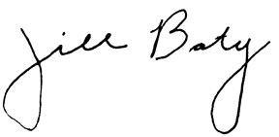

Jill Baty
Associate Planner
City of Fort Collins
970-416-8017
jbaty@fcgov.com

