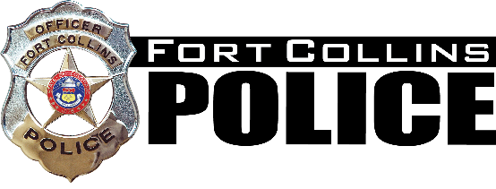
AGENDA
Chief’s Community Advisory Committee
Wednesday, April 19, 2023 | 12:00 p.m.
Fort Collins Police Services

1. OPENING
- Welcome and Roll Call
2. NEW BUSINESS
- HOPE Program Discussion
- Open Discussion
3. COMMITTEE QUESTIONS AND FEEDBACK
4. AGENCY UPDATES
6. IDEAS FOR FUTURE AGENDA ITEMS

